**Electronic Sales Dashboard Analysis**

The purpose of this dashboard is to analyze sales data from client orders in order to pinpoint important performance trends over time, product categories, and geographical areas for FGH Ltd.

Order ID, Product, Quantity Ordered, Price Per Unit, Order Date, Sales, City, and Hour are among the variables in the dataset.

I used pivot tables to group the data and create the following visuals

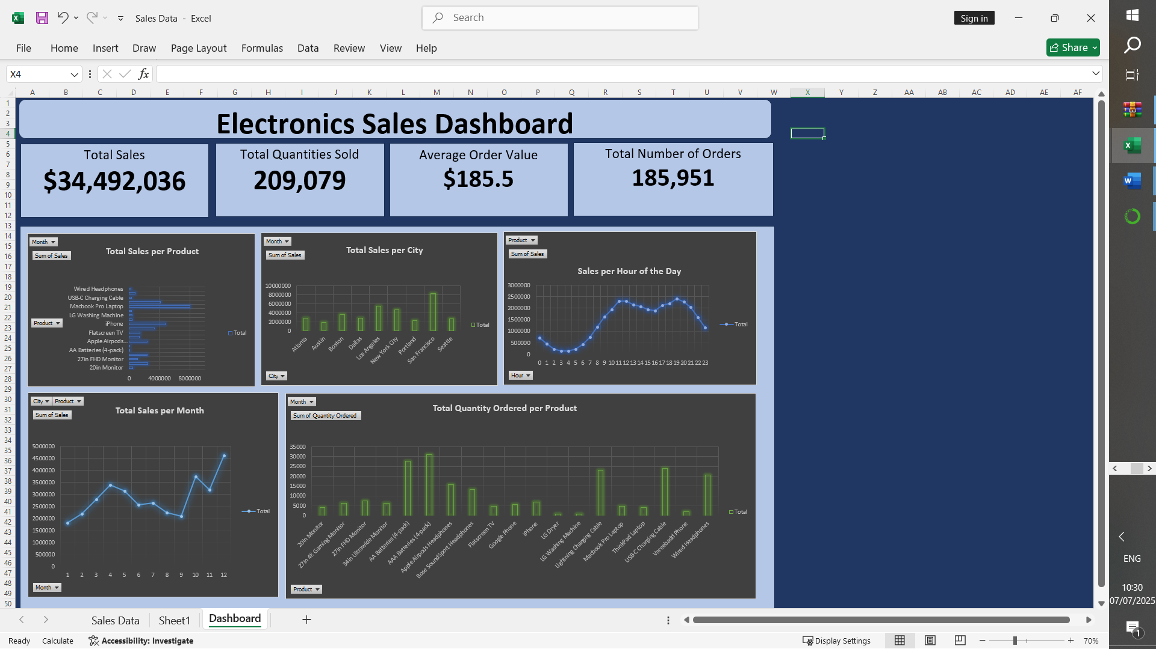

**Key Insights**

**1. Overall Performance**

* **Total Sales:** $34,492,036
* **Total Orders:** 185,951
* **Total Units Sold:** 209,079
* **Average Order Value (AOV):** $185.50

**2. Time-Based Trends**

* **Best Performing Month:** December with sales of $4,613,443.34
* **Peak Sales Hours:** Orders peak around 11am-12pm and 7pm in the evening, indicating optimal times for promotions.
* **Sales Growth Pattern:** According to the line cart visualization, the sales per month is seasonal with the highest sales being recorded during holidays and the festive season. The sales in the first months of the year increase linearly with a slight dip before the upward trend.

**3. Top Products**

* **Most Sold Product (by Quantity):** AAA Batteries (4-pack)
* **Top Revenue-Generating Product:** MacBook Pro laptop
* **Average Price Range:** Products range from $2.99 to $1700 in price.

**4. City-Level Insights**

* **City with Highest Sales:** San Francisco
* **Top 3 Performing Cities:** San Francisco, Los Angeles, New York
* **Geographical Sales Pattern:** The sales are highly concentrated on cosmopolitan areas which can be linked to high population.

**Recommendations**

* **Marketing Focus:** Concentrate promotions during peak hours 11am-12pm and top-performing months like December.
* **Inventory Planning:** Ensure high stock availability for MacBook Pro laptop in San Francisco.
* **Targeted Campaigns:** Use city-specific insights to run localized campaigns.

**Conclusion**

The business benefits significantly from seasonality, which presents a reliable opportunity for timed promotions and inventory management. Customers are most active during lunch breaks and after work. These are golden windows for digital marketing, flash sales, and email campaigns. Both low-cost, high-volume and high-value, low-volume products are critical. There’s an opportunity to cross-sell or bundle these strategically.

The organization should act on time-based promotions, inventory planning, and city-specific marketing while also bundling and forecasting smarter. This way they’ll see increased sales volume, improved profit margins and better customer targeting and retention